**Module 1 Critical Thinking Screencaps**

Adam Tubin

Colorado State University Global

Course Code: CSC372

Chintan Thakkar

9/28/2023

**Part 1 Output**

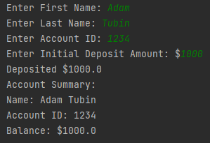

**Part 2 Output**



**Git**

